Ecosystems Engineering

Forgerock | 201 Mission St., Ste 2900, San francisco, ca 94105

EE Partner Portal

User’s guide

Legal Disclaimer 2

What is the Partner Portal? 3

Features 3

Partner Organizations 4

Organization Registration 4

Partner Users 6

Self-Service Password Reset 7

Organization Deployments 9

Structure of a Deployment 9

ForgeRock Modules Available for Deployments 9

Creating Deployments 10

Managing Deployments 11

Deploying the Environment 12

Deployment Dashboard 14

LDAP Provisioning Configuration 19

LDAP Connector Configuration 19

Mappings Configuration 20

AM User Store Configuration 21

Future Features 23

# Legal Disclaimer

The Partner Portal is intended to provide our System Integration and Technology Partners with resources they can leverage in the implementation of custom integrations, PoCs, demonstrations and training. These assets cannot be used to support Production Level Configurations, nor hosted environments for Customers.

Ownership of all software components powering the portal and all assets created through the portal is retained by ForgeRock. The Partner Portal will provide all the required interfaces and tools to facilitate the installation and deployment of custom code. The Administration Consoles of all Products included in a Deployment are available through the internet for the purposes of Feature Configuration relevant to the use cases being implemented using the Environment.

Additional functionality like E-Mail Notifications will have to be enabled through the Partner’s own e-mail server.

The availability of these resources will be limited by an assigned quota that can be adjusted at ForgeRock’s discretion.

# What is the Partner Portal?

The Partner Portal is a Central Location where our Global SI and our Technology Partners can get access to hosted resources that provide a Platform for them to leverage for development work, demos or as a training asset. The Ecosystems Engineering Team will support our Partners’ activities on the Partner Portal to ensure proper use of these resources and aid them in the implementation of functionality intended to fulfill their customer’s Non-Production requirements.

## Features

Through the Partner Portal our SI and Technology Partners can access the following features:

* Self Service Organization Management
  + Users
    - Self-Service Profile Management
    - Self-Service Password Reset
  + Deployments
    - Self-Service Create Custom Deployments
    - Self-Service Modify Custom Deployments
    - Self-Service Deploy/Un-deploy Components to/from Kubernetes Partner Cluster
    - Self-Service Distribute Custom Code to IDM, AM and/or IG
* Self-Registration
  + Organizations
    - Create New Organizations
  + Users
    - Self-Registration (All user accounts are subject to Portal Admin’s approval)
    - Self Service Password Reset

The above functionality is available on the current version of the Portal. All Deployments are currently supported on version 6.0 only. Future releases may be offered as they become **available** (early access releases may be made available in the future to choose from when specifying a deployment). Mixed version Deployments are not supported at this time.

Partner Organizations

## Partner Organizations

Partner Organizations in the Partner Portal allow Partner Companies to have visibility of all the Users and Deployments they may own as a single view. At this point the functionality is limited and it is merely informational. Subsequent releases of the Portal may include more interactive features that allow Administrators to reach out to Deployment Owners and get access to content published by Developers in their Organization.

## Organization Registration

This is the first step to get access to the assets available on the Partner Portal. At this point there is no distinction between a System Integration and a Technology partner, they both have to register their companies as a Partner of ForgeRock. This is accomplished in the Home Page of the Partner Portal. No login is required to Register your Organization and self-register as a user. The home page of the portal is located at the following URL: <https://pportal.fridam.aeet-forgerock.com/pportal/>

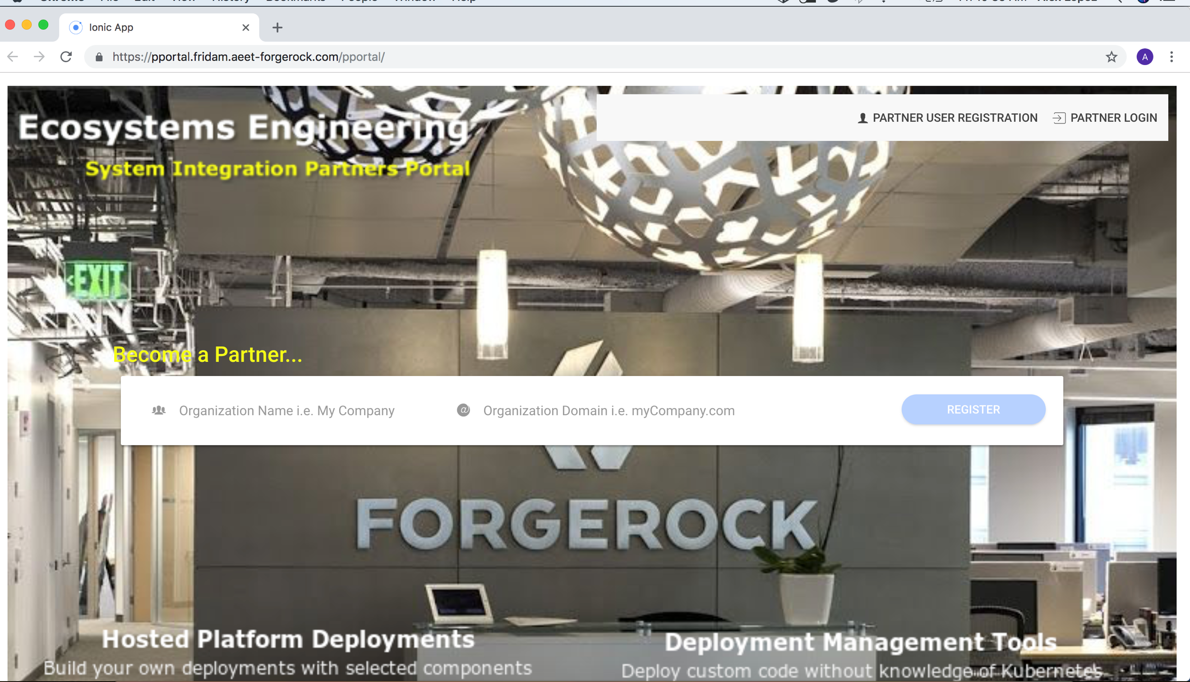

The Become a Partner… section allows Companies to Self-Register their Organizations. Enter a Descriptive Name for your Company and the domain portion of your Corporate E-Mail addresses. For example:

Organization Name: ACME

Organization Domain: acme.com

The Organization is created immediately if validation succeeds (If an Organization’s Domain already exists it won’t be created twice, even if a Different Organization Name is provided).

Partner Users

## Partner Users

Organizations have users that will consume the assets made available through the Partner Portal. The accounts used by these users can be created only via Self-Registration. The process for Self-Registration has the following requirements:

* The e-mail address must belong to an existing Organization’s Domain.
* The Password must comply with the Password Policy as Spelled out when the Password field gets the input focus. (See picture below)
* The user must configure 3 security questions for Password Reset.
* There is a reCAPTCHA prompt that needs to be submitted, certifying that the user is not a Robot. This is to prevent Bots and Automated entities from generating fake registrations.
* The user MUST accept the Terms and Conditions in order to proceed with the registration. Declining the Terms and Conditions will not allow the user to go any further.

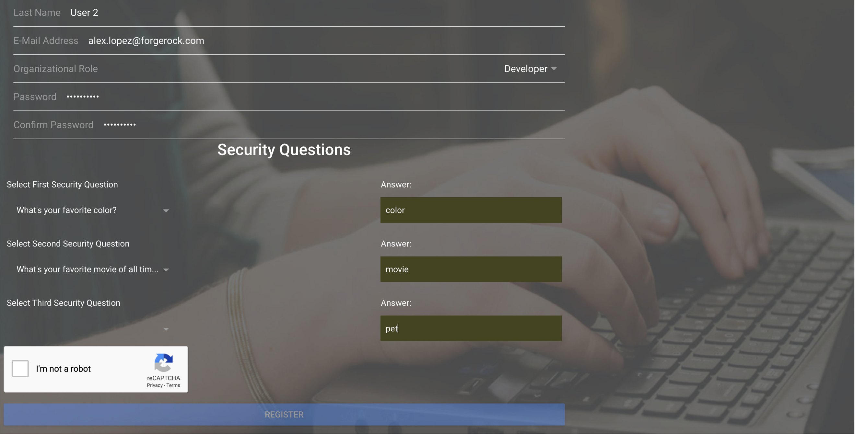

All fields on the Self-Registration form are REQUIRED. Once all the values are entered the REGISTER button gets enabled. Clicking the button will display the Terms and Conditions acceptance screen (see below).

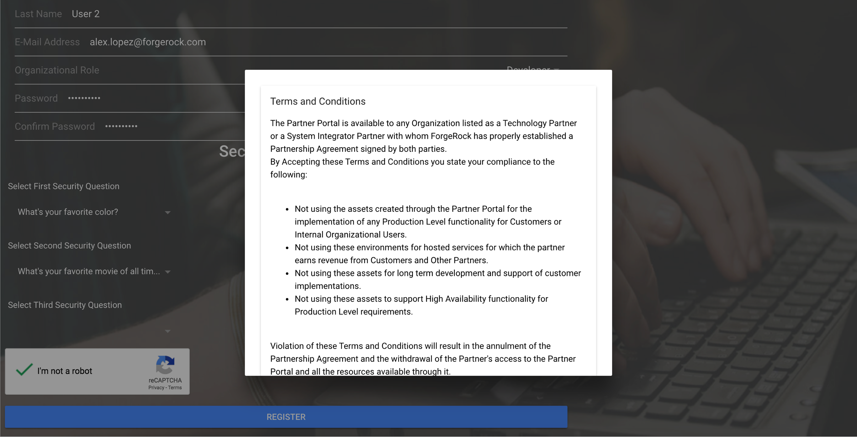

Scroll down to reveal the ACCEPT and DECLINE buttons. As stated before, in order to complete a Self-Registration request the Term and Conditions MUST be accepted.

As part of the process of Self-Registration, an E-Mail verification email is sent to the user in order to verify that the e-mail address entered is from the actual person. A link is contained in the e-mail that performs the verification. Once the users verify their e-mail addresses the account is created in the system, but it is disabled until the Portal Admins team reviews the request and approves the account. Once that happens, a second e-mail is sent to the user stating that the account has been approved. Un-approved accounts are submitted to the Organization’s Administrator for further review.

### Self-Service Password Reset

As part of the Self-Service capabilities provided within the Portal is the ability for users to reset their own passwords in a secure manner.

The password reset feature can be accessed in the Manage Profile page of the Portal. A Reset Password link is shown in the Manage Profile page. When users select that link, the following user interface is shown:

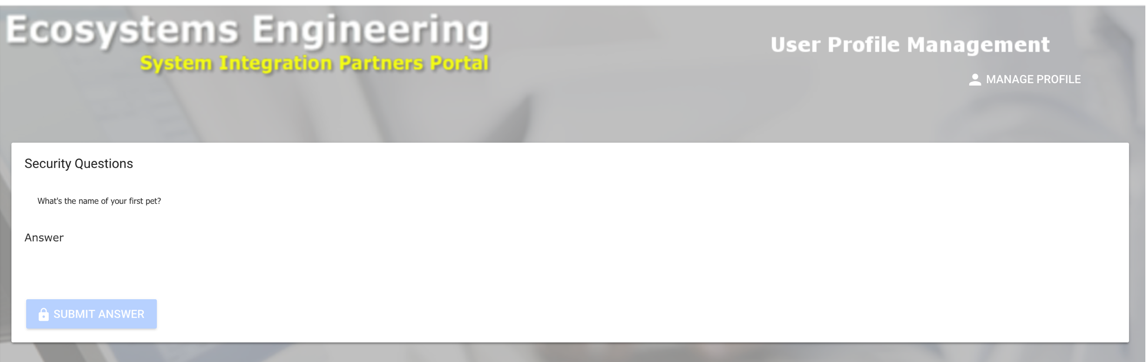

A randomly selected Security Question is chosen from the 3 questions configured at registration time. When users answer the security question correctly, they are then redirected to a page where they can reset their password. The interface is shown below:

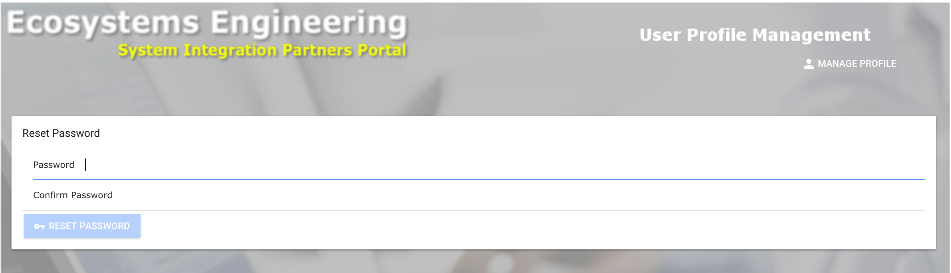

Organization Deployments

## Organization Deployments

One of the main objectives of this Partner Portal is to provide our SI and Technology Partners with a hosted cloud infrastructure that enables them by making it easier to get access to fully functional ForgeRock’s Platform installations that can be used in the implementation of functional requirements for development, demos and even training.

The tools available through the portal are also a good example of how easy it is to deploy ForgeRock’s solutions and how compatible they are with the DevOps paradigm.

By leveraging technology most of our Partners are familiar with, it is not required to learn new technologies to be effective using the assets available through the Partner Portal. In order to deploy custom code, all it is needed is to clone a GitHub-Based Private Deployment repository accessed in a secure fashion via SSH keys and upload the corresponding files (i.e. jars, JSON-based configuration files, libraries, etc.) to predesignated directories in the Repository and push them to GitHub, where the Partner Portal will grab them from and install them on the proper containers in Kubernetes.

## Structure of a Deployment

Portal Deployments are comprised of the following:

* A set of Deployment Units representing each ForgeRock product to be deployed and its dependencies (i.e. AMSTER Configuration Management for Access Management).
* A load balancer service that exposes access to the Administration Consoles of all the deployed products.
* A GitHub Private Repository for custom code distribution.

Deployments are kept separate from each other by a namespace. There is no validation of the uniqueness of the namespace at this point – this will be added soon, but in the meantime, it is recommended to partners to follow a convention to generate namespaces like adding a prefix representing the company. For instance: If a company called mytech has a project called dellpoc, a good namespace would be “mtechdellpoc”. This has very good chances of being unique. If a partner accidentally defines an environment on an already existing namespace, this can cause unpredictable results that may result in loss of data or component crashes.

## ForgeRock Modules Available for Deployments

The entire ForgeRock Identity Platform is available for Deployment including the following main modules:

* Identity Management
* Access Management
* Access Management in Debug Mode
* Identity Gateway
* Directory Services

Some additional components are necessary when the Identity Management and the Access Management modules are included in a Deployment. These are dependencies that need to be added to the deployments automatically when the Deployment includes AM and/or IDM. The dependencies are:

* Identity Management
  + PostgreSQL-Based Configuration Repository
* Access Management
  + Configuration Management Interface (AMSTER)

The interface to create deployments is shown below:

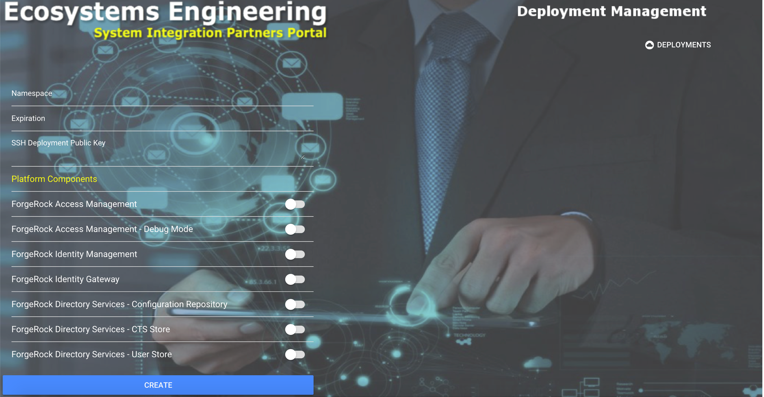

### Creating Deployments

In order to create a deployment, users must be assigned the Developer role. Follow the following steps to create your deployment:

* Log in to the Partner Portal (you must be a member of the Developer role)
* Select “Manage Deployments” from the top menu bar.
* Click the “+ CREATE” button above the list of current deployments you may have.
* Assign a Namespace to the deployment. This must be unique and be a single word, all lowered case no special characters, no dashes or spaces.
* Deployments must have an expiration date. At the expiration date, they will be undeployed and removed from the system. Deployments can be un-deployed and re-deployed at will without removing the Deployment from the system.
* SSH Deployment Public Key (Required): This must be set to the contents of the public key file generated using Open SSH or an SSH Key Generator of your choice. This is configured as a Deployment Key with Read and Write privileges in GitHub for the Repository linked to the Deployment. GitHub Private Repositories are used to distribute custom code and deploy it to the proper Kubernetes PODs (Kubernetes Execution Container Units).
* Select the Deployment’s Components using the switches to the side of each Module’s name. The dependencies will be automatically injected before submitting the deployment.

### Managing Deployments

All the Deployments owned by the logged in user are listed as shown below:

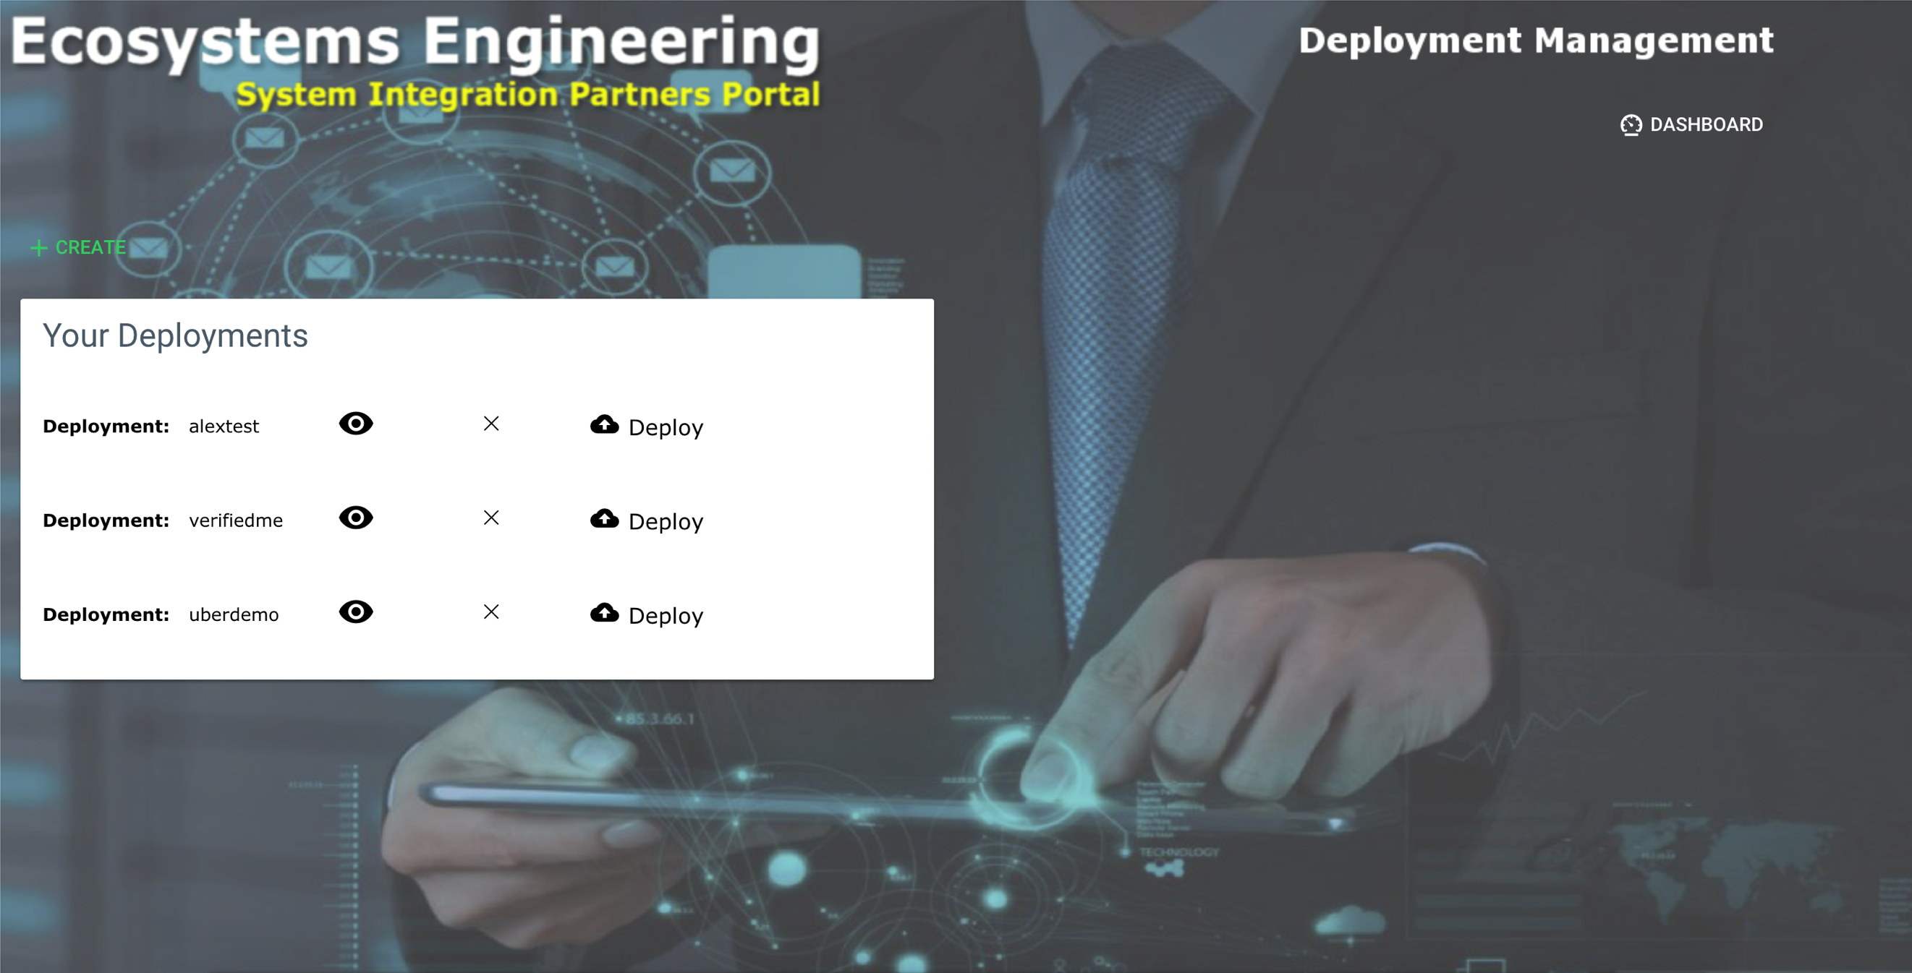

From this screen you can perform the following actions:

By clicking the Eye icon, the Modules enabled in the Deployment and their dependencies are displayed. See the picture below:

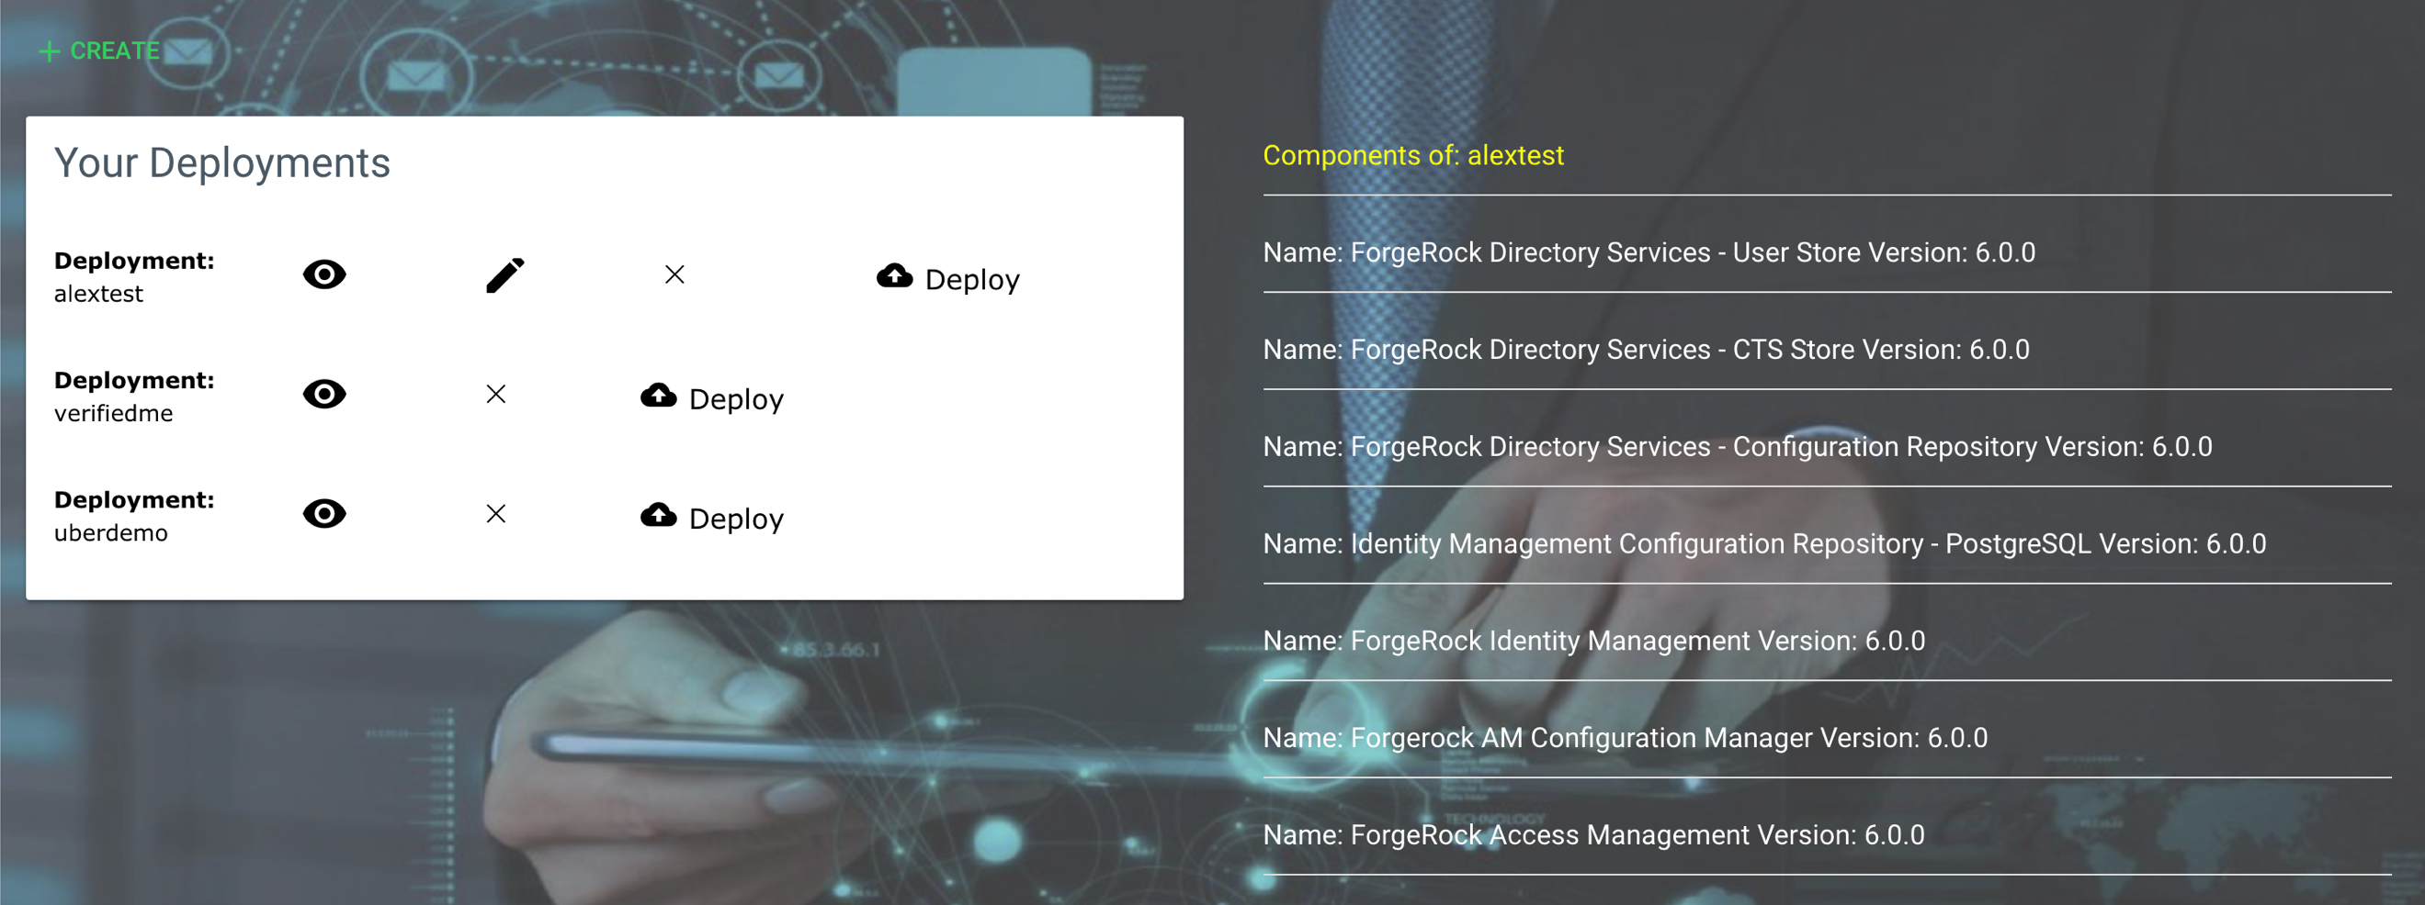

When the components of a Deployment are listed, another option is presented to modify the definition of the Deployment. Clicking the ‘Pencil’ icon takes you to a screen similar to the create deployment form where the user can edit the definition as necessary. **Note, when Deployments are ‘Deployed’, they can’t be modified; in order to do so, they must be Un-Deployed first.**

### Deploying the Environment

After creating the Deployment Specification with the desired components, the Deployment options get enabled.

* The Deployment process involves the following actions:
* Creates the SSL Secrets for each Component in the environment
* Creates a Load Balancer service in the cluster under the Namespace specified for the Deployment
* Installs the Modules using Helm (Kubernetes Deployment Manager)
* Updates the Deployment status to true (Deployed) – But the environment is not **ACTIVE** yet.
* After all PODs (Component Containers in Kubernetes terms) are up and running, the Activation process is started.
* In the Activation phase the following actions are taken:
  + Create an SSH Deployment Key Pair
  + Create a GitHub private repository for the Deployment
  + Sets the SSH Public Key generated above along with the SSH Public Key provided by the Deployment’s owner as Read/Write Deployment Keys in GitHub
  + Configures the Git Repository with a predefined Directory Structure so the deployment of custom code is enabled.
  + Updates the status of the deployment to Active

#### Deploying

To Deploy Environments a User must Login to the Partner Portal as a Developer and navigate to Manage Deployments.

A list of Deployments owned by the User is displayed. To Deploy the environment the User must click the **Deploy** button. The following screen shows the Deployment initiation:

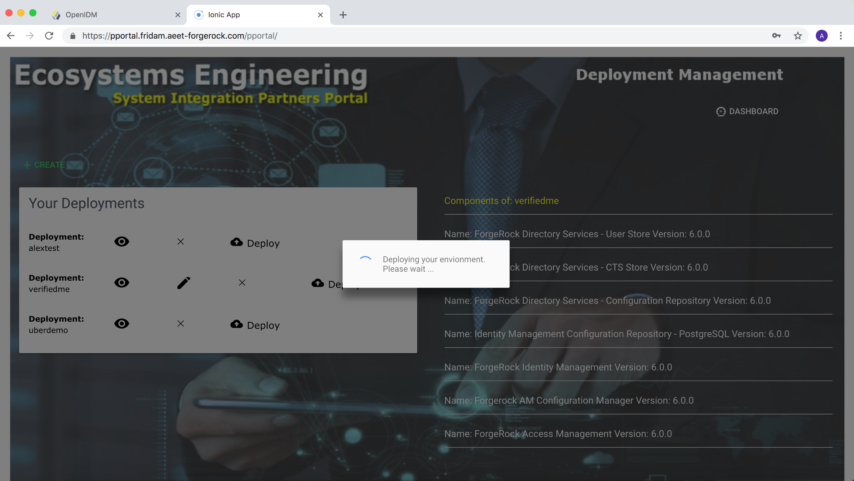

When the Deployment is complete and before the Activation phase starts the following Screen is presented to the User:

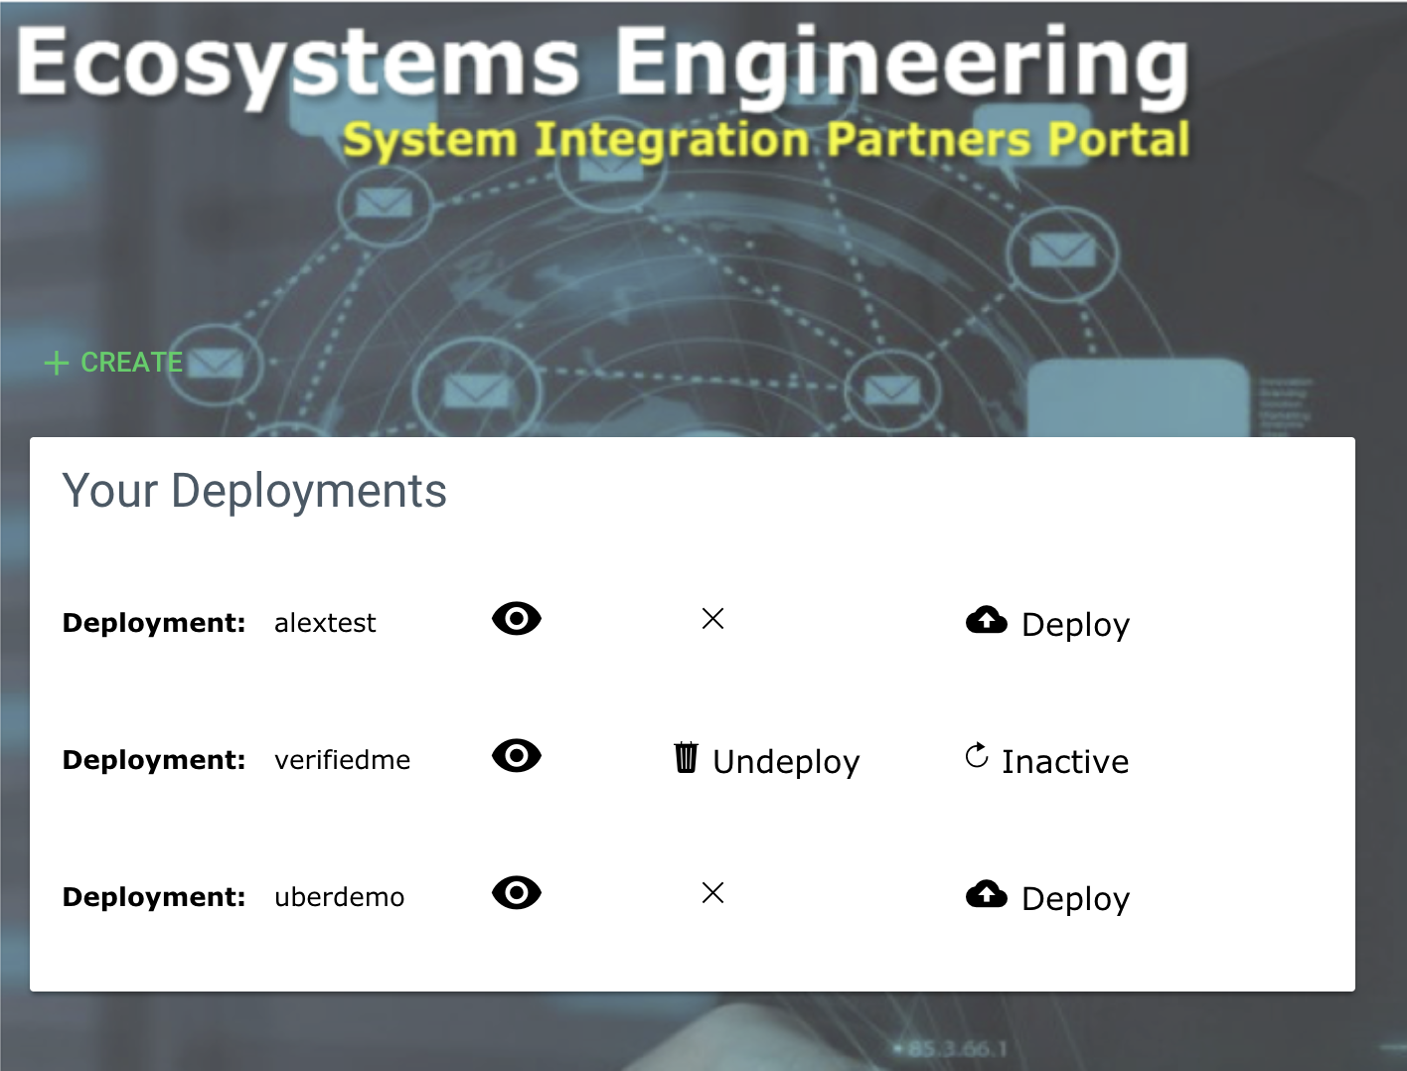

A button labeled as **Inactive** shows up in the row for the Deployed Namespace. Click that button until it turns into the word ‘Active’, see below:

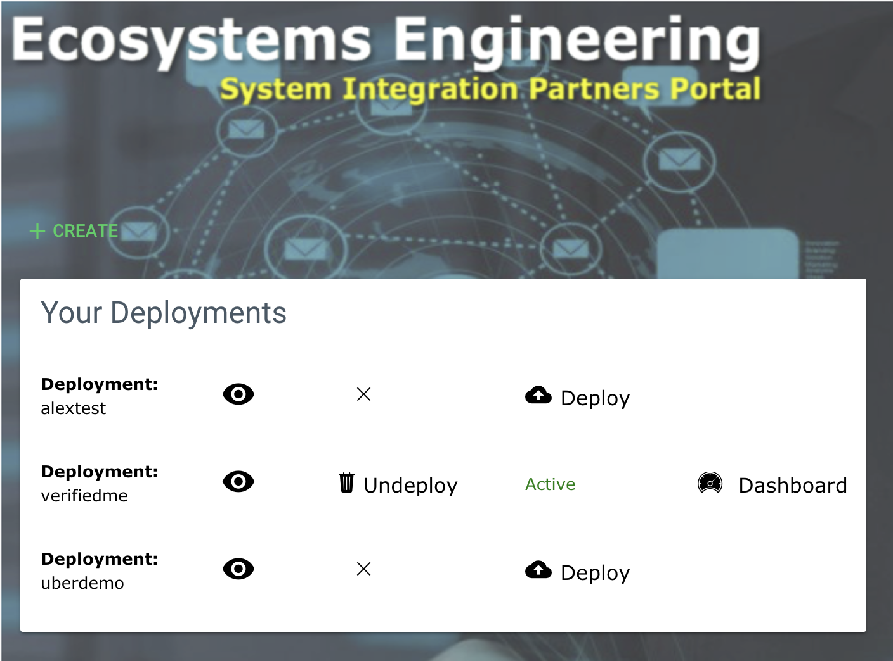

Typically, it takes about 5 to 7 minutes to completely start all the Containers in a Namespace. The status of a recently deployed Namespace can be checked using the **Inactive** button at any time, even if the User logged out and logged back in later.

Once a Namespace is shown as ‘Active’, the **Dashboard** button is enabled. If the **Dashboard** button is not visible, click on the ‘Eye’ button to display the components that a Deployment has and that should present the **Dashboard** button.

### Deployment Dashboard

The Deployment Dashboard is the console from where Users access the Module’s Administrative and Self-Service consoles and also initiate the installation of custom code or configuration. See the screen below for instance:

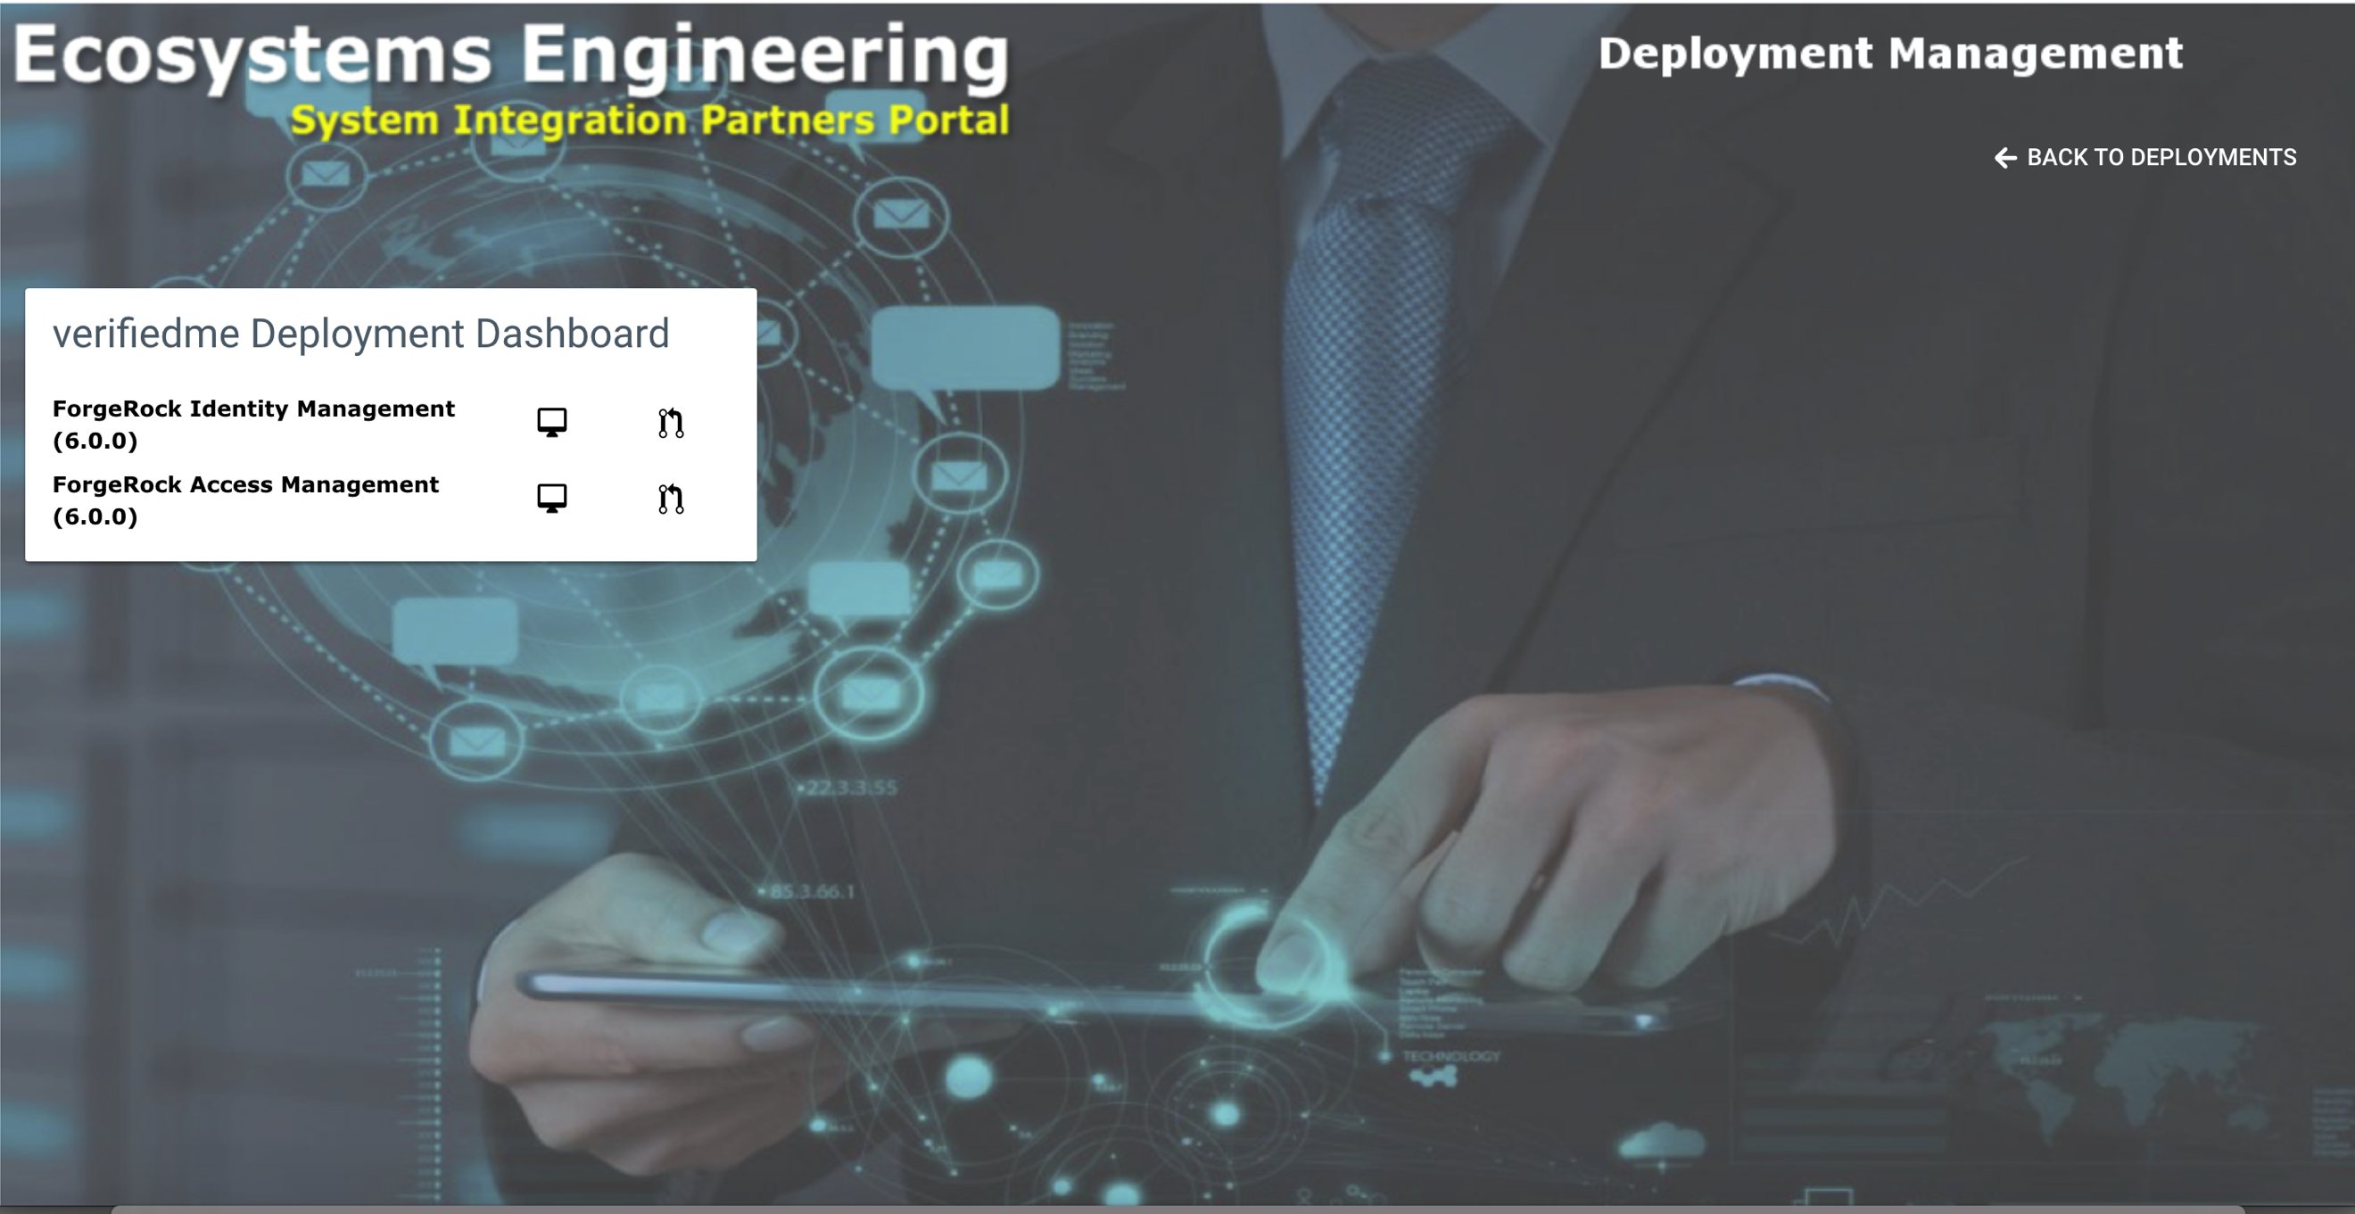

As shown in the picture, all the Deployment’s components that allow remote installation of custom code and/or configuration will be listed here. There are two buttons:

* The button with the Workstation Icon allows the User to access the Administration Console of that Component.
* The button next to the Workstation allows the User to display the current contents of the Deployment Repository associated to the Environment. This is used when distributing custom code and/or configuration.

#### Code and Configuration Distribution

The Partner Portal makes some very useful tools available to our Partners for them to distribute their custom code and configuration to their deployed Namespaces. To showcase these tools, consider the following use case:

“As part of an Integration with a Secure Access Platform a System Integrator has developed a set of Authentication Tree Nodes for ForgeRock’s Access Management. The SI has an Environment Deployed through the Partner Portal and is about to distribute their custom components to the running instance of Access Management in their environment”.

In order to accomplish the Distribution of their custom files, the SI will have to execute the following actions:

* Clone their Deployment Repository locally.
* Copy the jar files to the proper directory for AM: <path to the repository clone’s home directory>/default/am/custom-jars

Note: The path /default/am/custom-jars is a predefined directory in the deployment repository where developers can place their custom developed jars for Authentication Modules and Custom Tree Nodes. All the predefined directories for customizations deployment will be documented in this guide as well.

* Execute the following commands:

$ cd <git repo clone home>

$ git add .

$ git commit -m “Your comment”

$ git push

Once the files are uploaded to the Git Deployment Repository they will be accessible to the Partner Portal. The owner of the Repository should now log in to the Partner Portal with their Developer accounts and access the Deployment Dashboard. The following screen shows the listing of the just uploaded files:

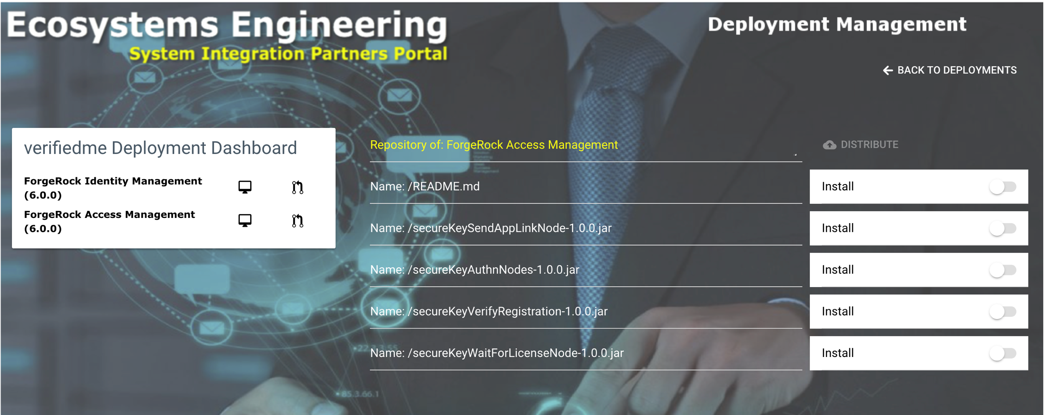

Select the files you want to distribute to the AM container in the Deployed Environment. See below:

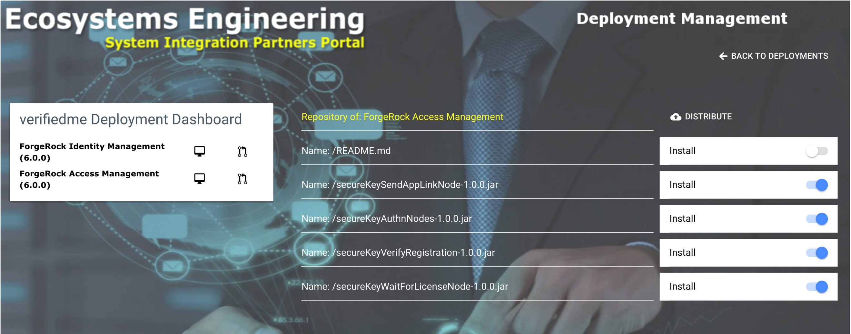

To start the distribution, click the **DISTRIBUTE** button.

The Distribution process does the following:

* Pulls the latest changes from the Deployment Repository on the Portal side.
* Copies the files from the Deployment Repository into the Container of the AM POD using Kubernetes CLI.
* Restarts the AM POD using Kubernetes CLI.

Note: When the POD is restarted, the Startup script of the Application Server (Tomcat in this case) contains an invocation of a customization shell script which copies the JAR files from their persistent volume path into OpenAM’s web application’s lib directory in Tomcat’s HOME; this happens after changing the permissions of the existing files in the container’s persistent volume directory where the JAR files reside. The files can’t be copied directly to Tomcat’s HOME because when the container is restarted, those files will be wiped out since they are not in a persistent volume.

To verify the Distribution success, the SI logs in to the Environment’s AM Admin Console (clicking the Terminal Icon on the Deployment Dashboard of the distribution target environment and logging in with the administrator’s credentials). Since the JAR files were supposed to be Custom Authentication Tree Nodes, in order to verified if they were distributed correctly a New Authentication Tree must be created. The following pictures show what was just described above:

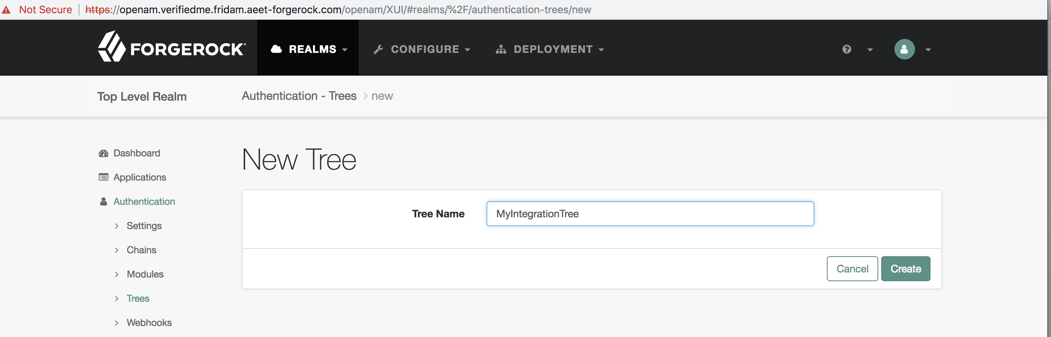

Scroll down till the new Custom Nodes appear:

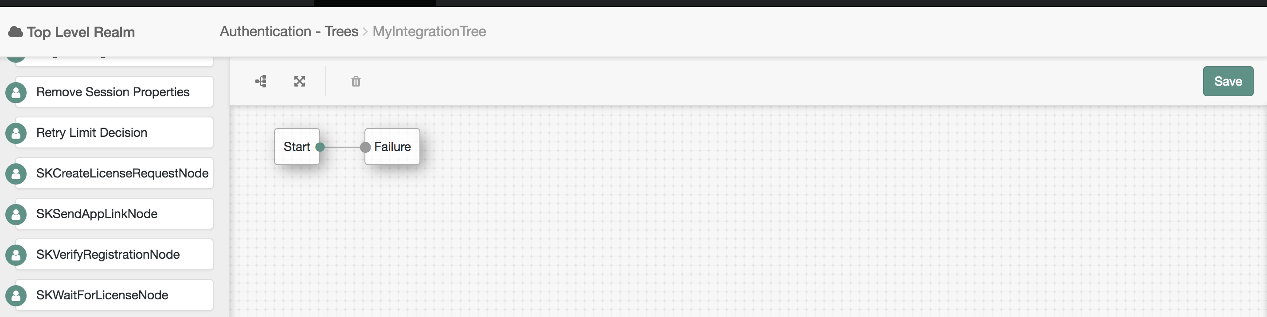

The SK<…> nodes now appear on the left side pick list ready to be added to the Authentication Tree.

###### Deployment Repository Pre-Defined Distribution Directories

Each main component part of a Deployment is associated with a distribution directory (DD) in the Deployment Repository. The DD is the location used by the portal to extract the newest code or configuration files to be deployed onto the corresponding POD (Kubernetes Container).

The Distribution Directories per component are listed in the following table:

|  |  |  |
| --- | --- | --- |
| Component Name | Customization Type | Distribution Directory on GitHub |
| Open AM | JAR Files (Authentication Tree Nodes, Custom Authentication Modules) | /default/am/custom-jars |
| Open IDM | * Workflow Definitions (*.bar) * Custom End-Points Configuration (*.json) * Custom End-Points Scripts (*.js and *.groovy) | /default/idm/custom |
| Open IG | Custom IG Route Configuration files (.json) | default/ig/basic-sample/config/routes |

#### Working with Access Management Debug Mode instances

The Partner Portal allows our partners to include an instance of Access Management that is enabled for remote debugging. The ForgeRock Access Management – Debug Mode 6.0.0 is available to be added to any deployment. Deployments containing ForgeRock Access Management in Debug Mode are deployed just like any other deployment. The difference shows in the Deployment Dashboard, which shows an additional button, see below:

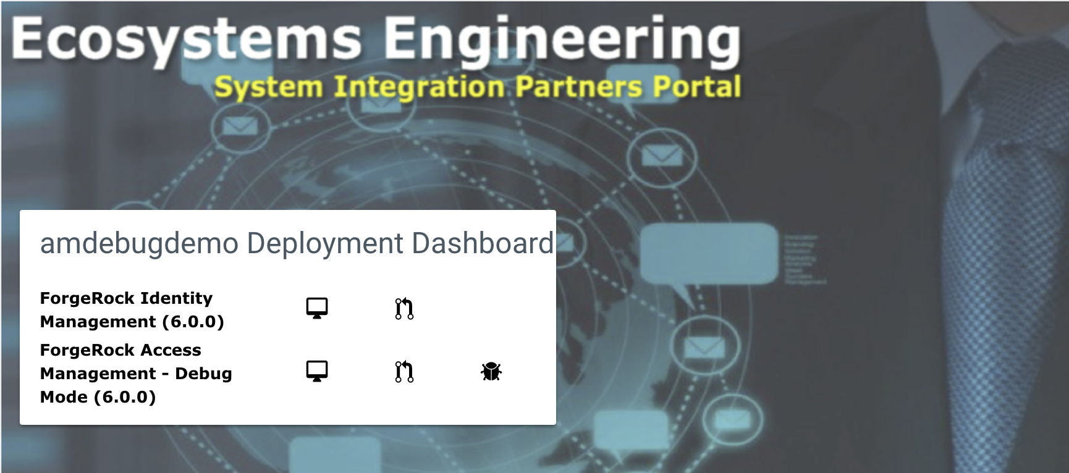

As shown in the picture above, a third button appears on the row for the ForgeRock Access Management – Debug Mode (6.0.0) showing a Bug. Clicking on that button displays the URL that can be configured on an IDE (i.e. IntelliJ IDEA Ultimate Edition or Eclipse) for remote debugging. The following picture shows this information:

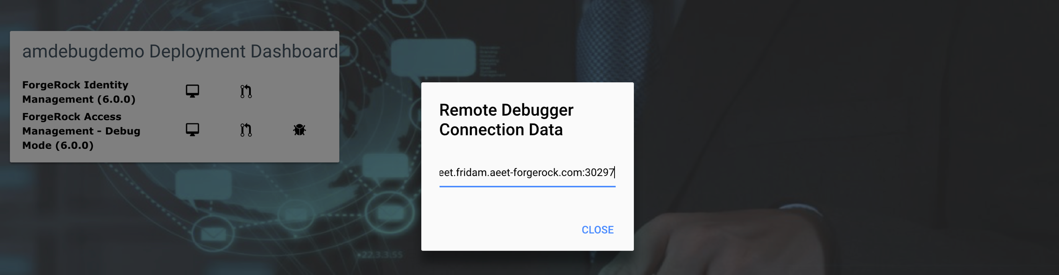

The URL shown above is: debug.aeet.fridam.aeet-forgerock.com:30297 which means that the port 30297 is attached to a remote debugger enabled in Tomcat running OpenAM web application. This port is made available through Kubernetes via a service that exposes the port mentioned there. This port is unique to the deployment. The Bug button can be clicked any time and as many times as needed and it will display the same information. Only one developer can be connected to the debugger at any given time. You can verify the availability of the port via telnet (see below):

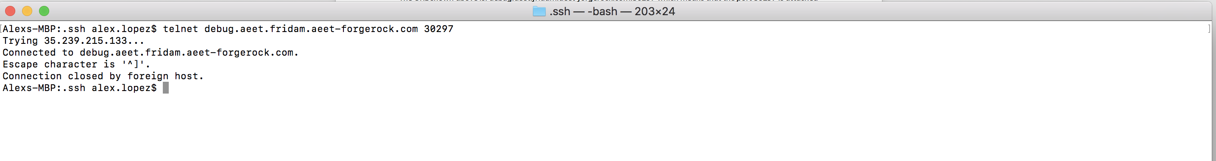

The telnet call comes back after a few seconds because the port in Tomcat doesn’t block until a remote debugger connects to it, but the port is available for connections nonetheless.

This functionality is particularly useful in situations like debugging custom code for Authentication Tree Nodes and Modules.

# LDAP Provisioning Configuration

Some of the configuration as it is, needs to be modified in order to work properly. Follow the instructions below to make the changes.

## LDAP Connector Configuration

This configuration is required for the LDAP connector which is automatically setup for the IDM module if included in a Deployment. The following actions need to be taken to modify the Connector’s configuration so that it will work properly during reconciliation and auto-synchronization of IDM users into the LDAP User Store:

Login to the IDM Admin Console of the Deployment in question. This can be done through the Deployment Dashboard in the Partner Portal.

Access the Configure | Connectors. Select the LDAP Connector from the Dashboard. The following screen should appear:

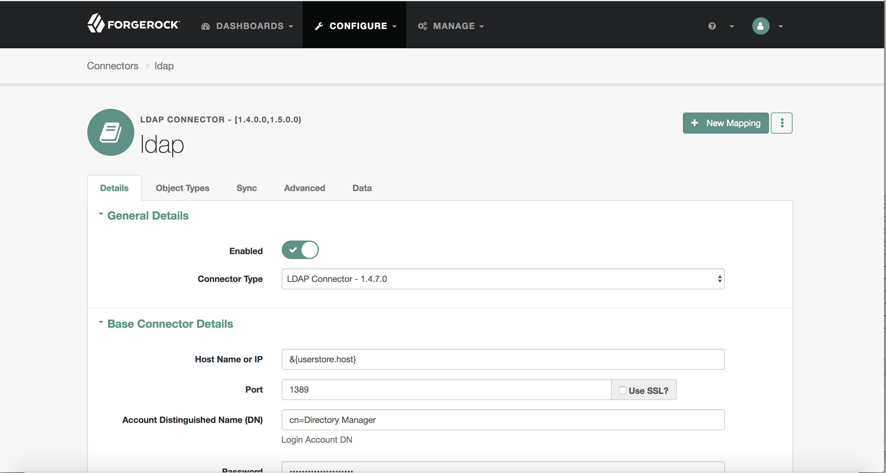

Replace the following values:

Host Name or IP: Enter userstore-0.userstore

Account Distinguished Name (DN): Leave it as cn=Directory Manager

Password: Enter ‘password’ as the Password.

Base DN: Enter o=userstore

Click Save.

## Mappings Configuration

Another portion of configuration that needs to be fixed is the Mappings between IDM accounts and LDAP. This affects the way in which new users are synchronized to LDAP’s user store. To correct this configuration the following actions are required:

Login to the IDM Admin Console (if not already there).

Navigate to Configure | Mappings | Managed User -> System/LDAP/Account

Scroll down to reveal the userName property mapping like shown in the following picture:

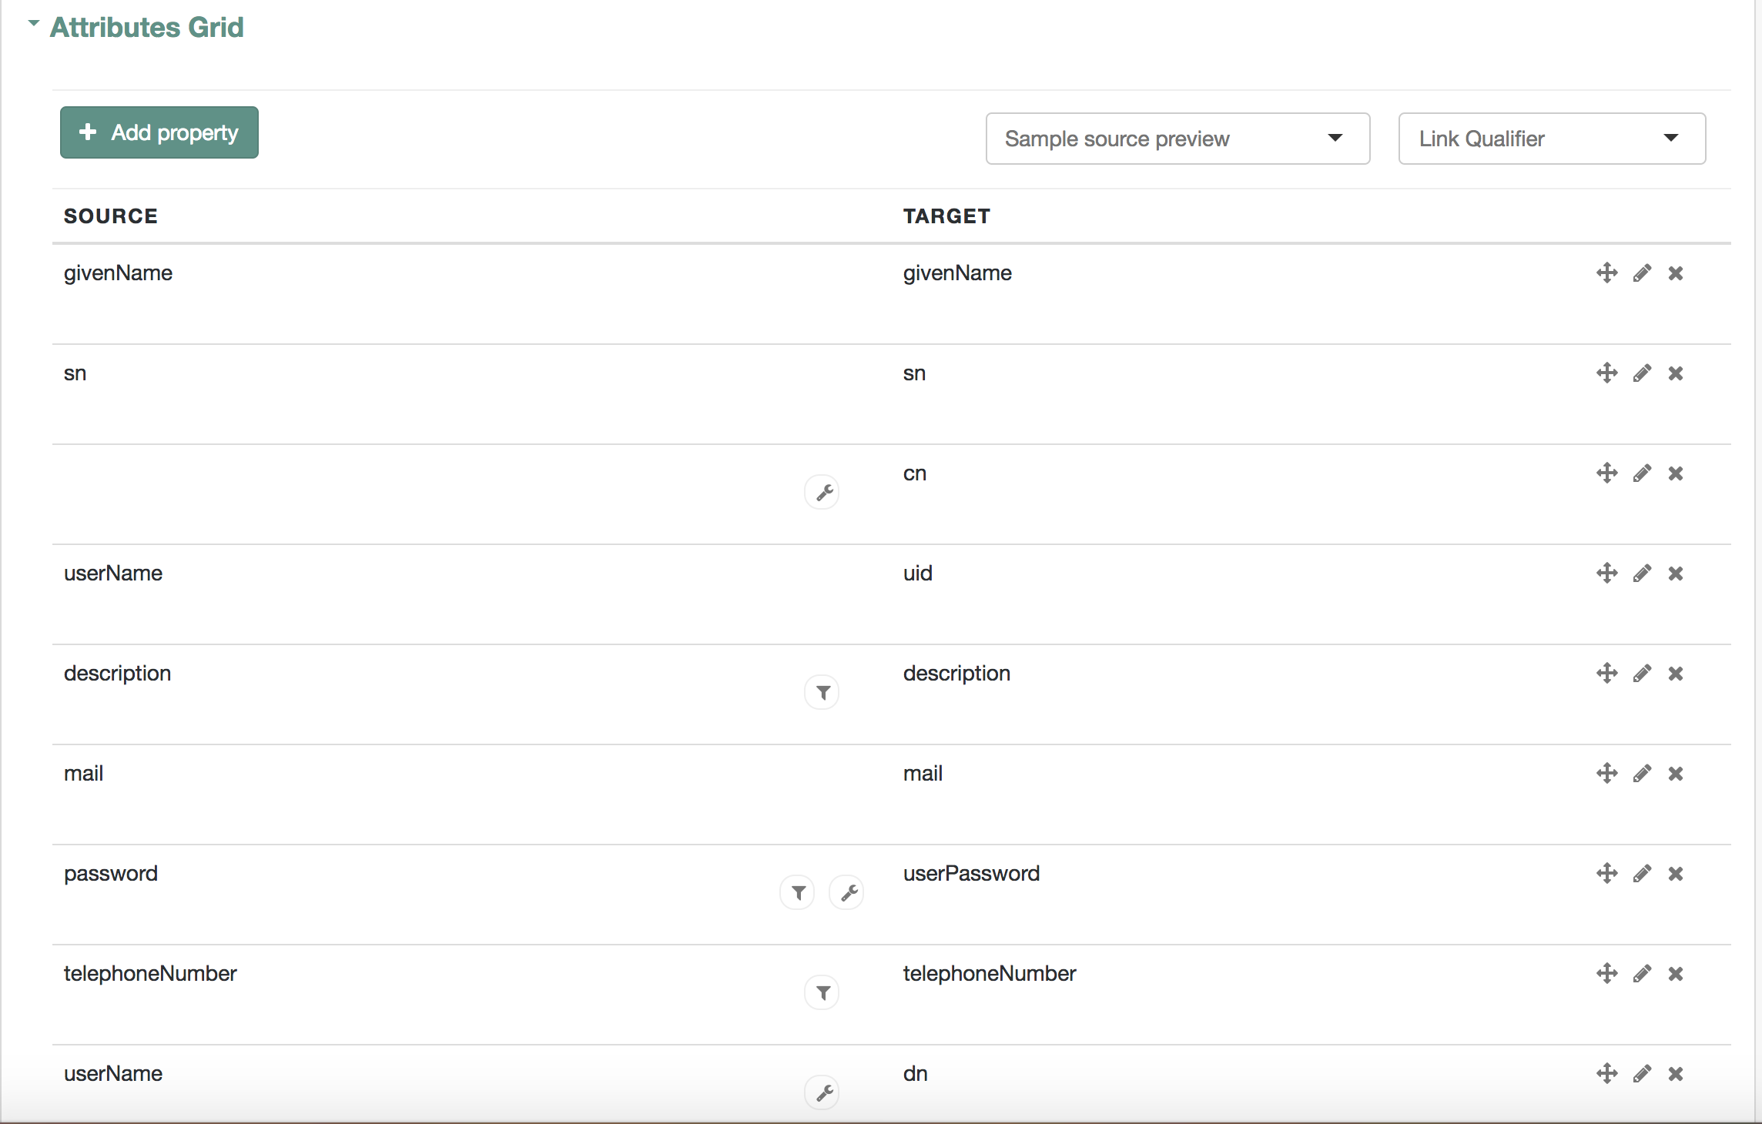

Click on the wrench icon and switch to the Transformation Script tab (see below):

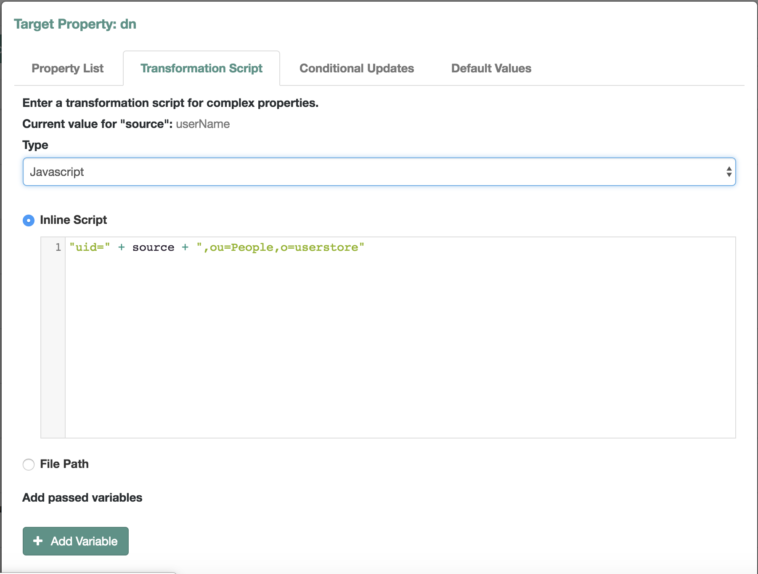

In the Inline Script text area, replace whatever is there with what you see in the picture above: “uid=” + source + “,ou=People,o=userstore”. Click the Save button to persist the changes.

Switch to the Behavior tab and scroll to the bottom of the page where the Situational Event Scripts are. There should be a Script tied to the onCreate Event. Edit the script by clicking the Pencil icon. The following should be displayed:

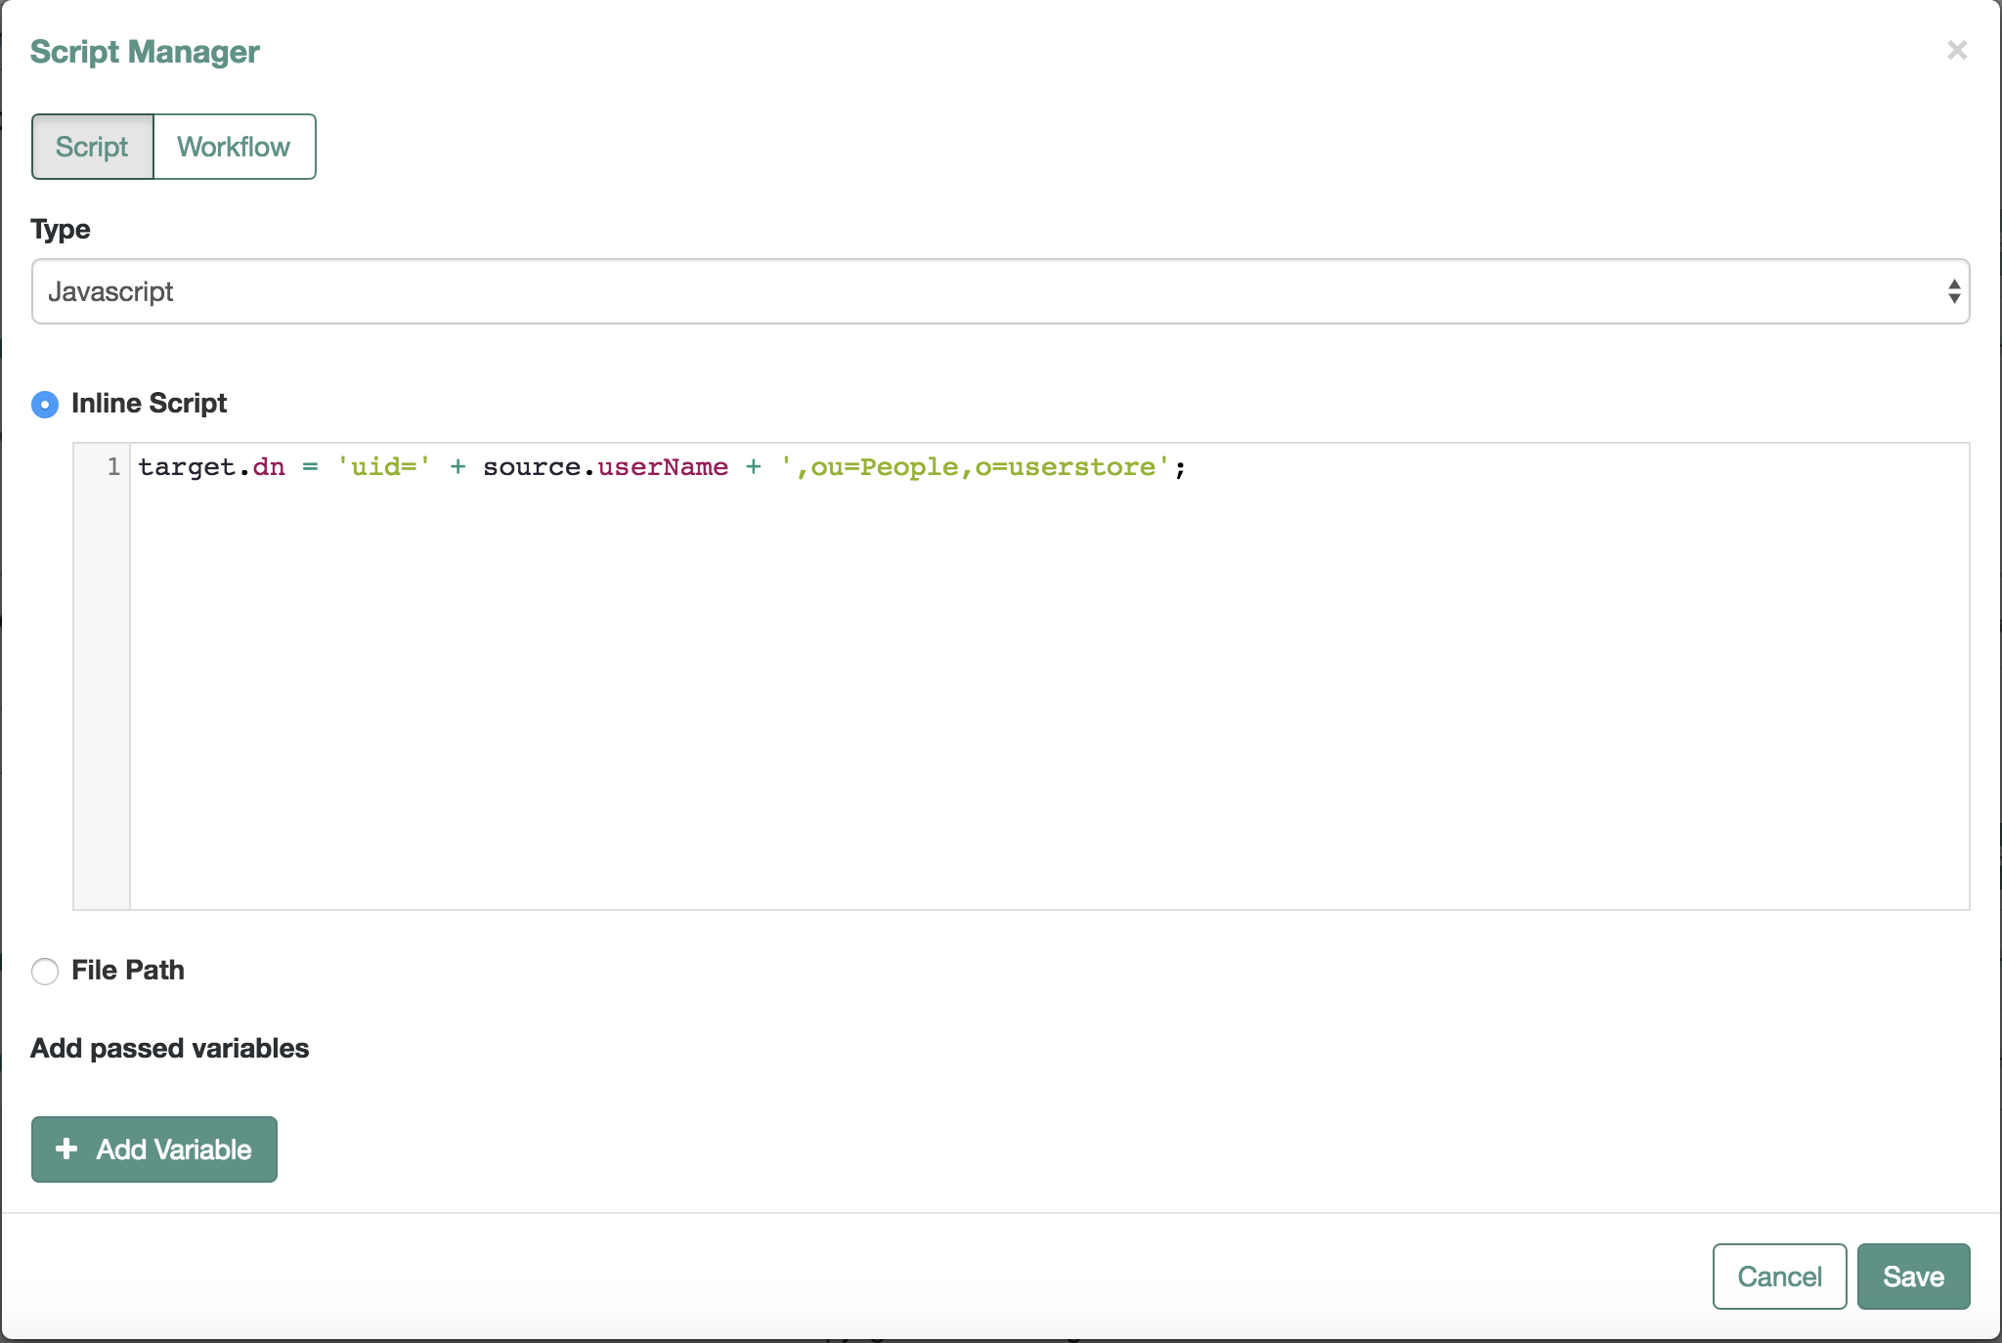

Replace the contents of the Inline Script text area with what is shown in the picture above: target.dn = 'uid=' + source.userName + ',ou=People,o=userstore';

Click the Save button and once the window is closed make sure to also click the Save button on the Situational Event Scripts section (see picture below). Failure to do so won’t save the changes properly.

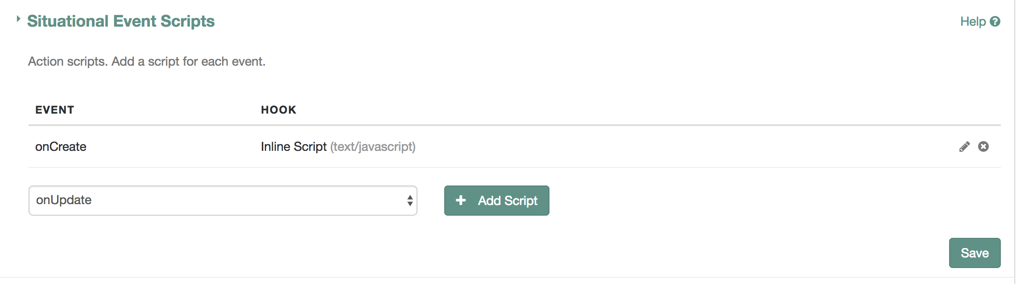

## AM User Store Configuration

In order to be able to use the LDAP Instance for the **userstore** to authenticate users provisioned by IDM when protecting applications with AM, a data store must be created in AM. The following actions are required to do so:

* Login to the Deployment’s AM Admin Console with **amadmin** credentials. User: amadmin Password: password.
* Navigate to Data Stores and Click the button “+ Add Data Store”.
* Provide a descriptive name, like “LDAP User Store” and click “Create”.
* Enter the information as shown in the picture below (LDAP Bind Password is: password):

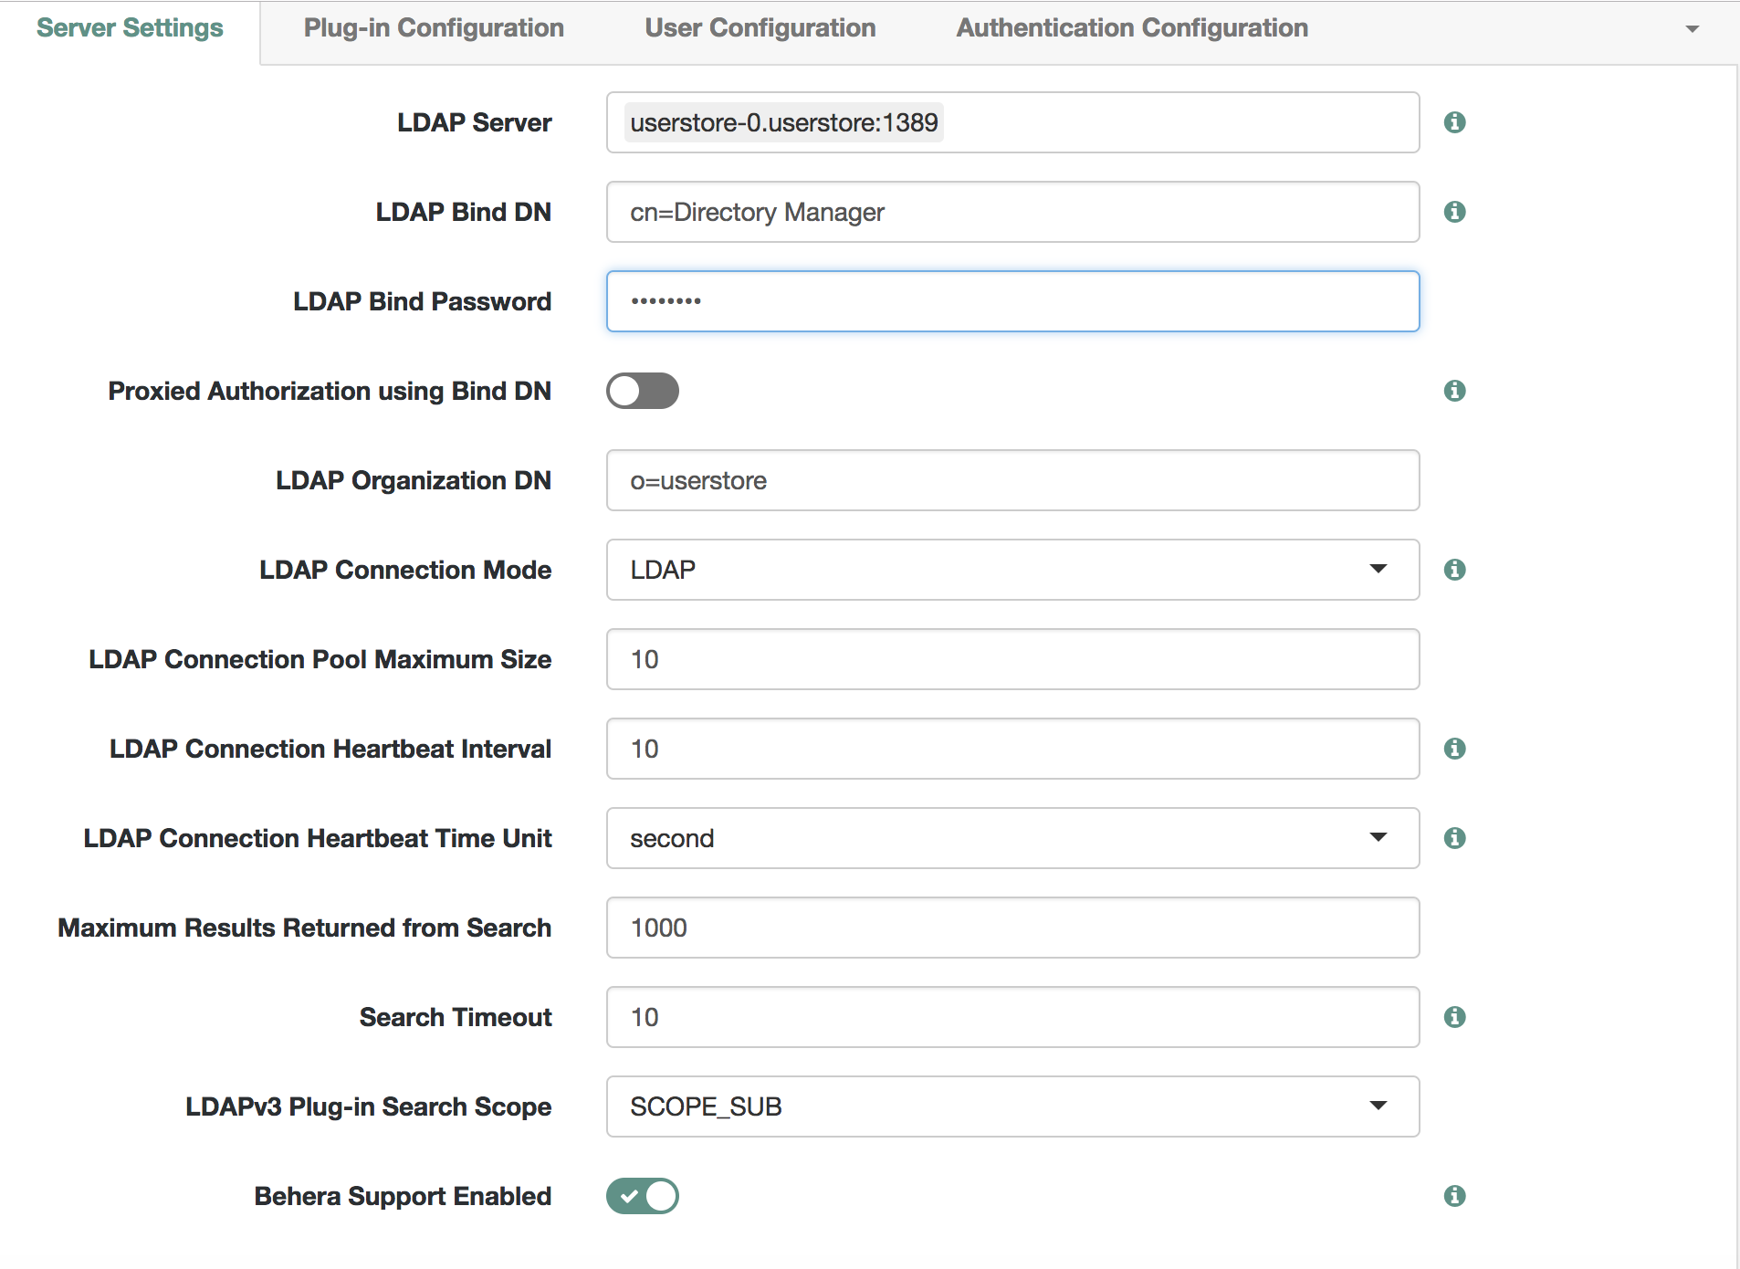

When done click the Save button to persist the changes.

If there are any Identities already present in the User Store, they can be displayed by navigating to the Identities (this option is in the left side menu 3rd from the bottom).

At this point AM and IDM instance should now share the same User Store and you can use them to protect applications with AM for users provisioned by IDM.

# Future Features

This section describes some of the new features we intend to release through the Partner Portal.

The more our Partners use this infrastructure the more feedback on new features we will get and hopefully be in position to incorporate some of those suggestions as new features.

As of today, we have identified a small set of features that will fulfill specific requirements from some of our partners from the Technology side. Here they are:

* Configuration Templates: These templates are meant to encapsulate the configuration required to implement a use case. These can be used to have predefined, ready to go assets that allow for the demonstration of FR’s Platform advanced capabilities in situations where a particular Vertical Specific Use Case is to be shown, potentially to a customer or a Partner’s Customer.